# 

Downloading the VM (includes data sets)

Alternative - download data sets

Virtual machine setup

Using Oracle VirtualBox

Using VMWare

# Downloading the VM (includes data sets)

1. Download it from <http://content.udacity-data.com/courses/ud617/Cloudera-Udacity-Training-VM-4.1.1.c.zip>. Warning - the zipped file size is 1.7 GB. *If you are on a Windows machine you will likely need to use WinRAR to open this .zip file because other methods fail to open the unzipped file (which exceeds the maximum specified 4GB for a .zip file).*
2. MD5sum file can be found here <http://content.udacity-data.com/courses/ud617/Cloudera-Udacity-Training-VM-4.1.1.c.zip.md5>
3. Unzip it. Warning - the unzipped size is 4.2GB
4. MD5 hashes for files:
   * 8a610c151d4b1ebdce11542d13dd2a53 Cloudera-Training-VM-4.1.1.c.log
   * 6b44c965c1c6062554bf4cc12d11e87e Cloudera-Training-VM-4.1.1.c.plist
   * 46dedeba3e0affd8311431d7e370705e Cloudera-Training-VM-4.1.1.c.vmdk
   * d41d8cd98f00b204e9800998ecf8427e Cloudera-Training-VM-4.1.1.c.vmsd
   * 096956c1cbabeaa652ca63a2d5e14612 Cloudera-Training-VM-4.1.1.c.vmx
   * c9f8a375e82ef1e9d96097850e237df9 Cloudera-Training-VM-4.1.1.c.vmxf
   * 0d7c8becb5a515068e81bb303c794e4f nvram

# Alternative - download data sets

Download and unzip data sets from:

* <http://content.udacity-data.com/courses/ud617/access_log.gz>
* <http://content.udacity-data.com/courses/ud617/purchases.txt.gz>

# Virtual machine setup

## Using Oracle VirtualBox

1. Download and install VirtualBox from <https://www.virtualbox.org/wiki/Downloads>
2. Create a new Virtual machine:
   1. Create a new virtual machine by pressing the ‘New’ button:  
      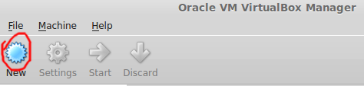
   2. Choose a name, use ‘Type’: ‘Linux’: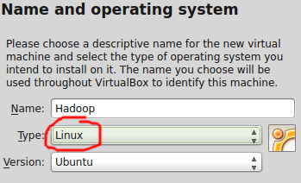
   3. Press Next
   4. Select memory size for the VM.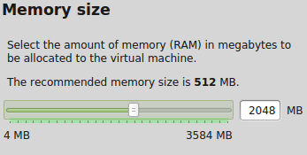
   5. Press Next
   6. Select ‘Use an existing virtual hard drive file’’, click the button to browse to the directory you unzipped the provided VM image and press ‘Create’.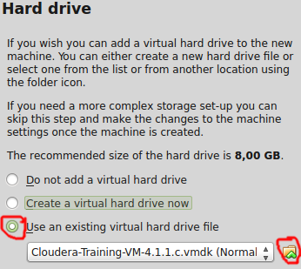
   7. Start the VM!  
      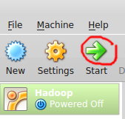

## Using VMWare

1. Download and install from <https://my.vmware.com/web/vmware/free#desktop_end_user_computing/vmware_player/6_0>
2. Create the Virtual Machine:
   1. Click on ‘Open a Virtual Machine’ and, when prompted, navigate to the folder you unzipped the VM, choose the file and click ‘Open’.  
      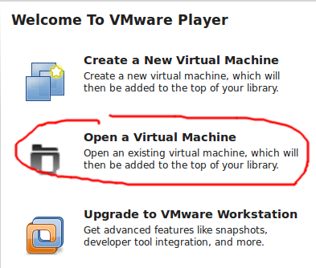
   2. Select the machine and click ‘Play virtual machine’